Prabin Neupane

I've never had any professional training in the arts, but creating art has always been how I unwind, interpret the world, and communicate my innermost thoughts and feelings. What began as a small pastime, sketching in notebooks and doodling on bits of paper quickly developed into something much larger and more fulfilling. I came to see that this was more than simply a hobby for me. It was my calling, my destiny. Because technology allows me to create entire worlds, create characters, and bring stories to life in a way that feels almost magical, 3D modeling particularly fascinates me. I find it exciting to think of fusing cutting-edge technology with my creativity.

While drawing as a hobby I never thought of specific and has been drawing emotions that I felt, so my drawing contains motivation and emotions from some series that I was watching or some manga that I have been reading. I have placed picture 6, picture 7 and picture 8 reflecting on those aspect to prove that I am motivated from the surrounding elements and use it as fuel to create a work. The remaining work are my own creative thought, dedication and style.

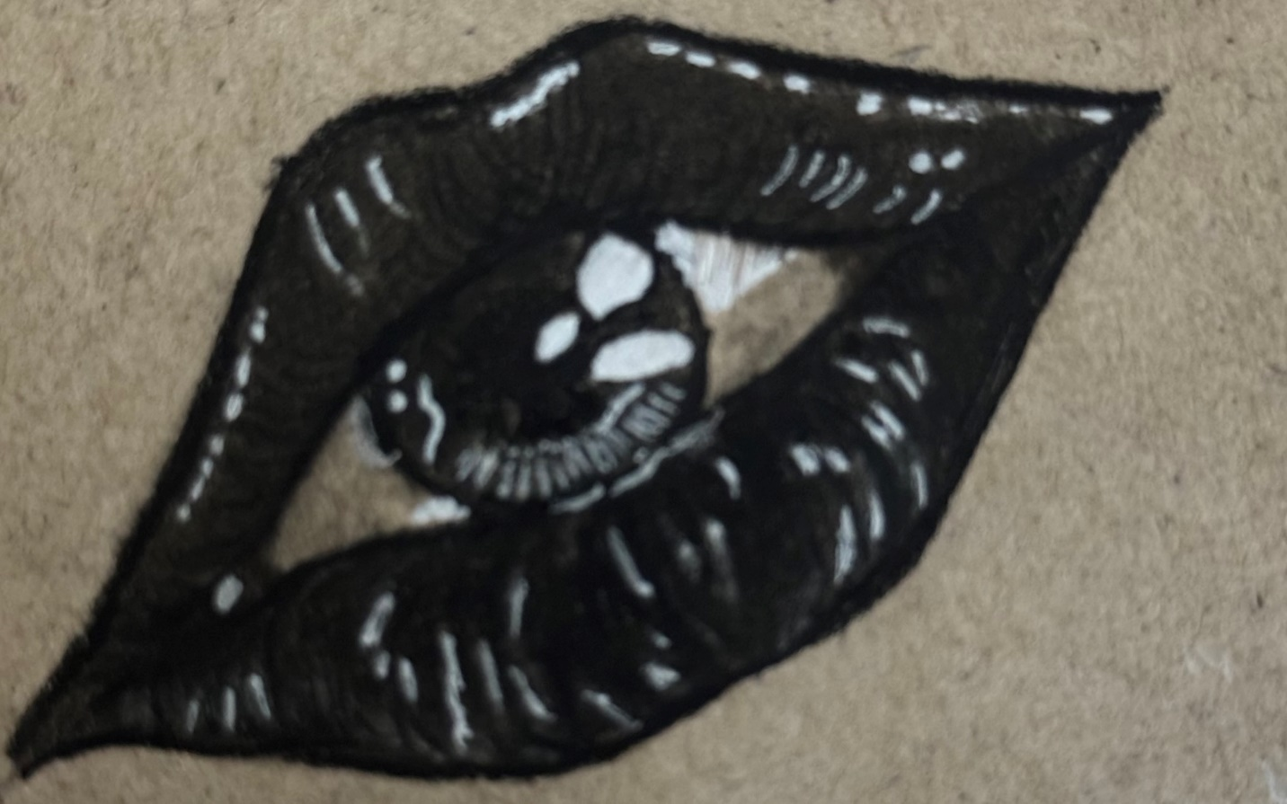Title: Looking lips

Figure : Picture 1

Tools: White pen, charcoal pencil on hard paper

Description: The art above portrays eye of a spearker who cannot say a word but stare through illusions and confusions of life.

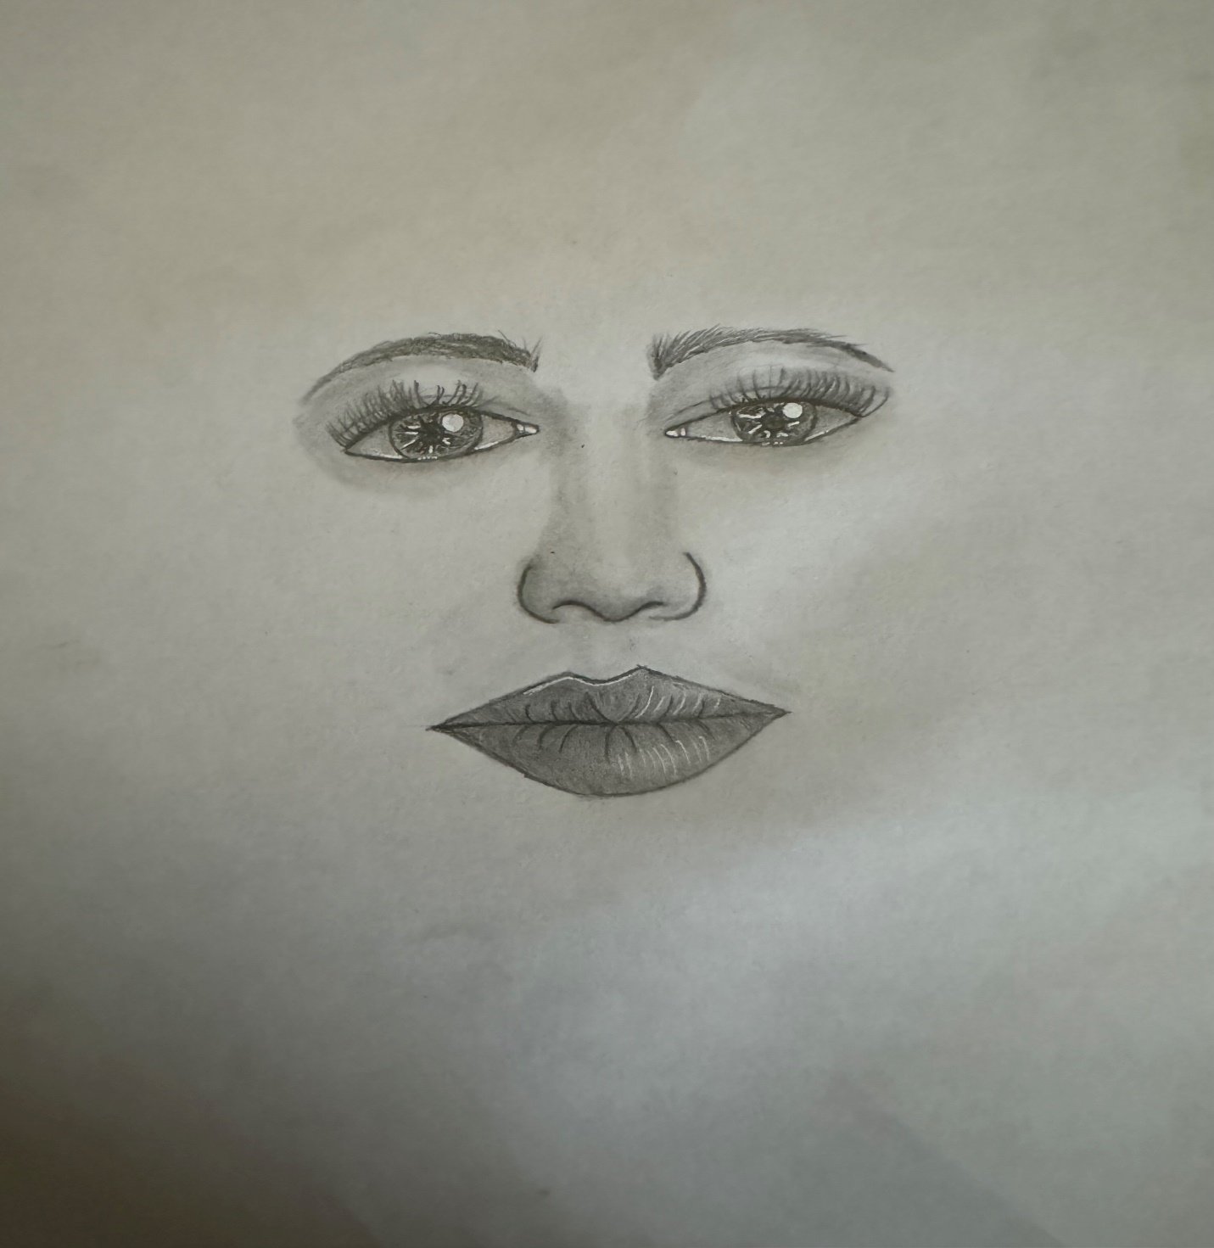

Figure : Picture 2

Title: Phase through

Tools: Graphite pencils on paper

Description: Though it looks incomplete, it portrays as phasing from the harsh and hostile nature of day-to-day life where the white background symbolizes hope in the darkness.

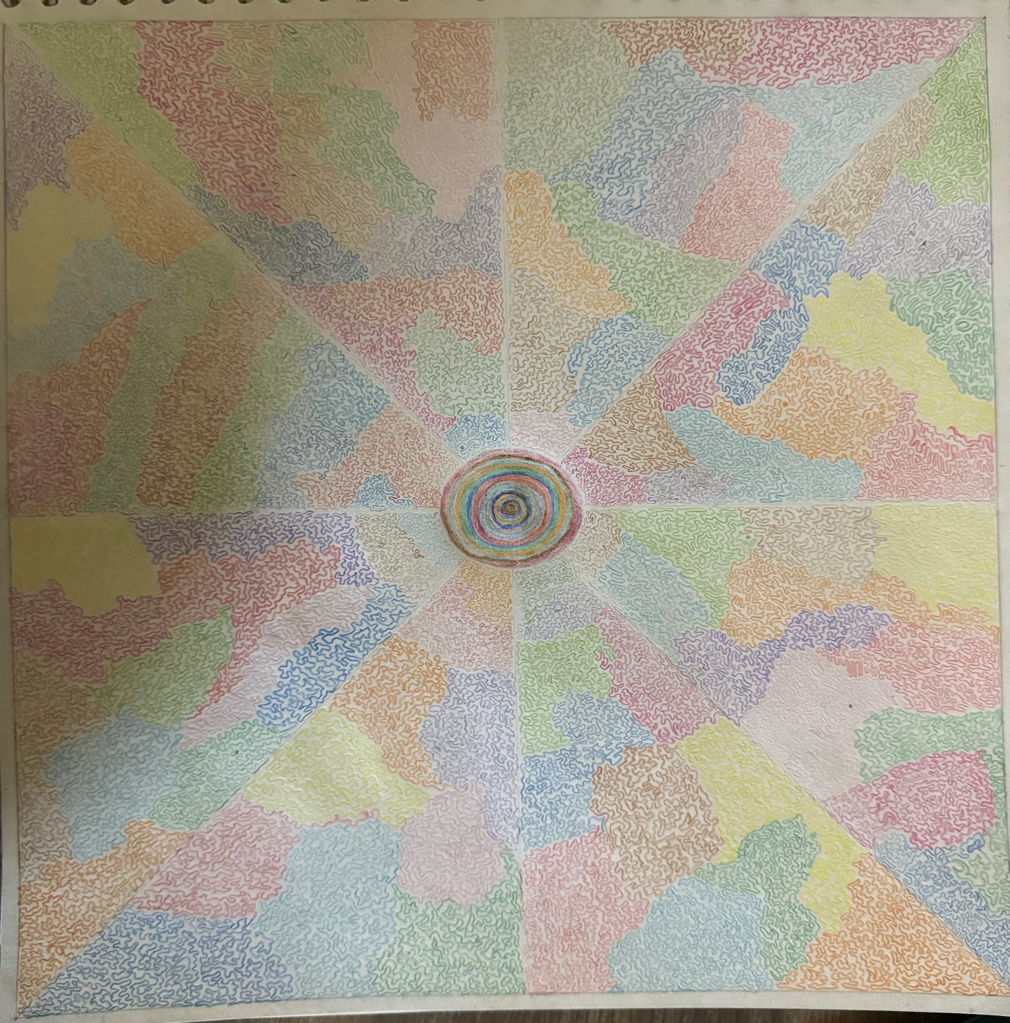

Figure : Picture 3

Title: Random

Tools: Color pencils on paper

Description: The art is compilations of random thoughts and emotions that is felt throughout the day, colors represent my inner emotion and those cranky line describes my random thoughts.

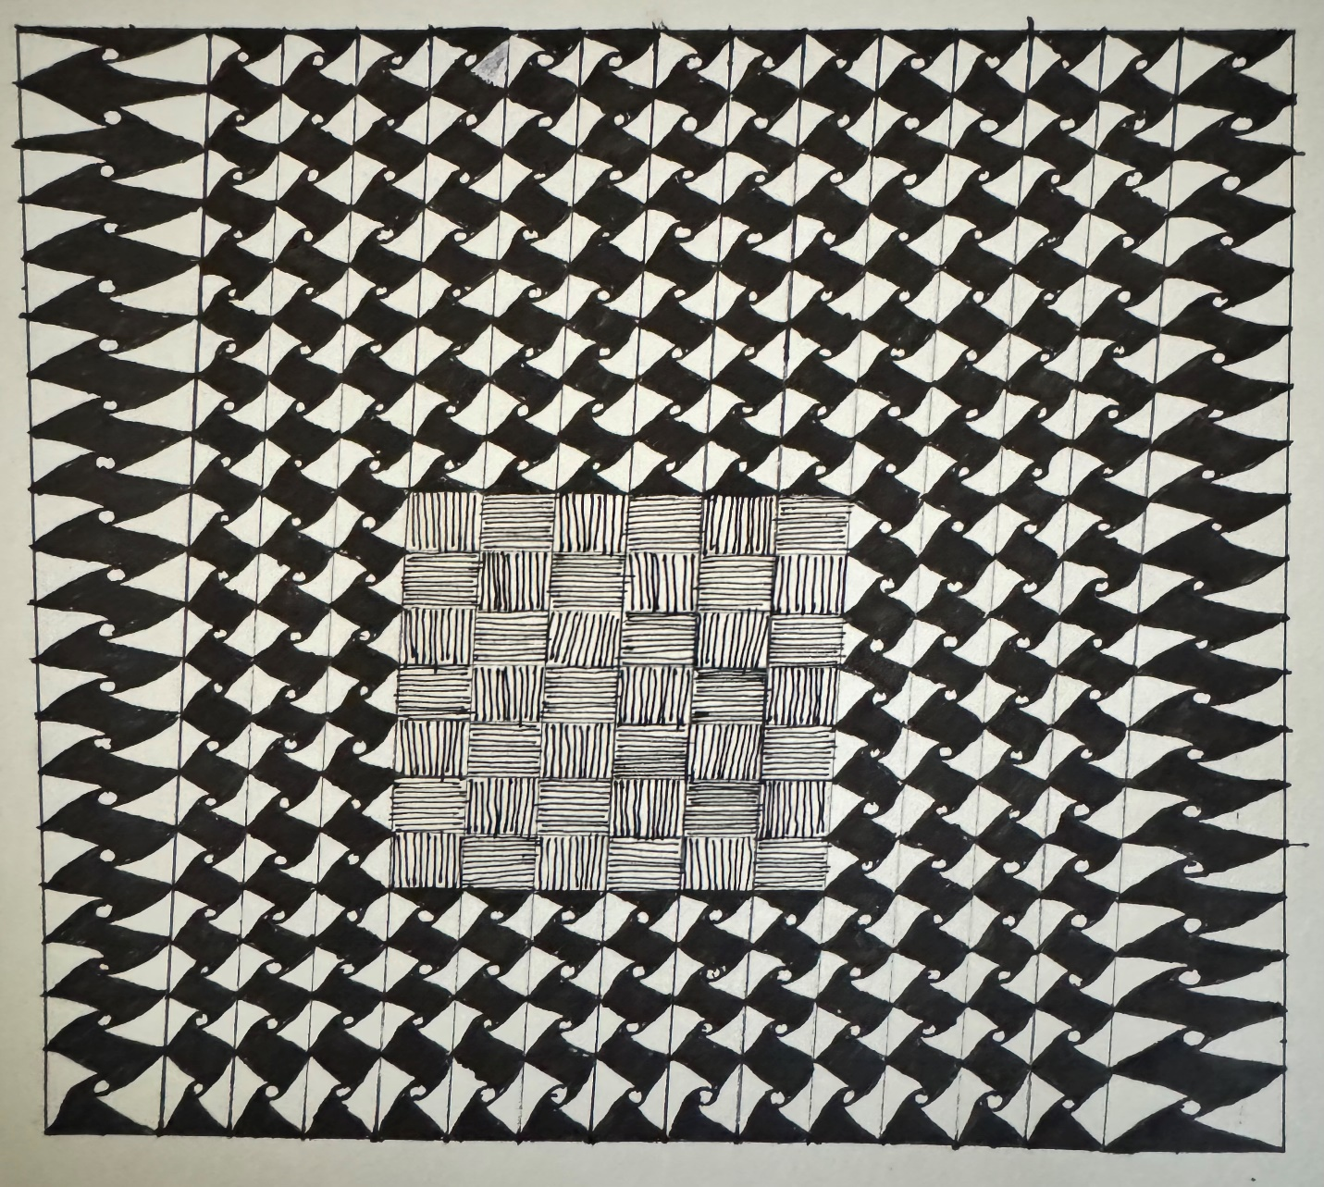

Figure : Picture 4

Title: Passion

Tools: Marker pen, pen on paper

Description: It represents the bottled passion inside of man who has a family to take care of. Inspired by watching my father activities.

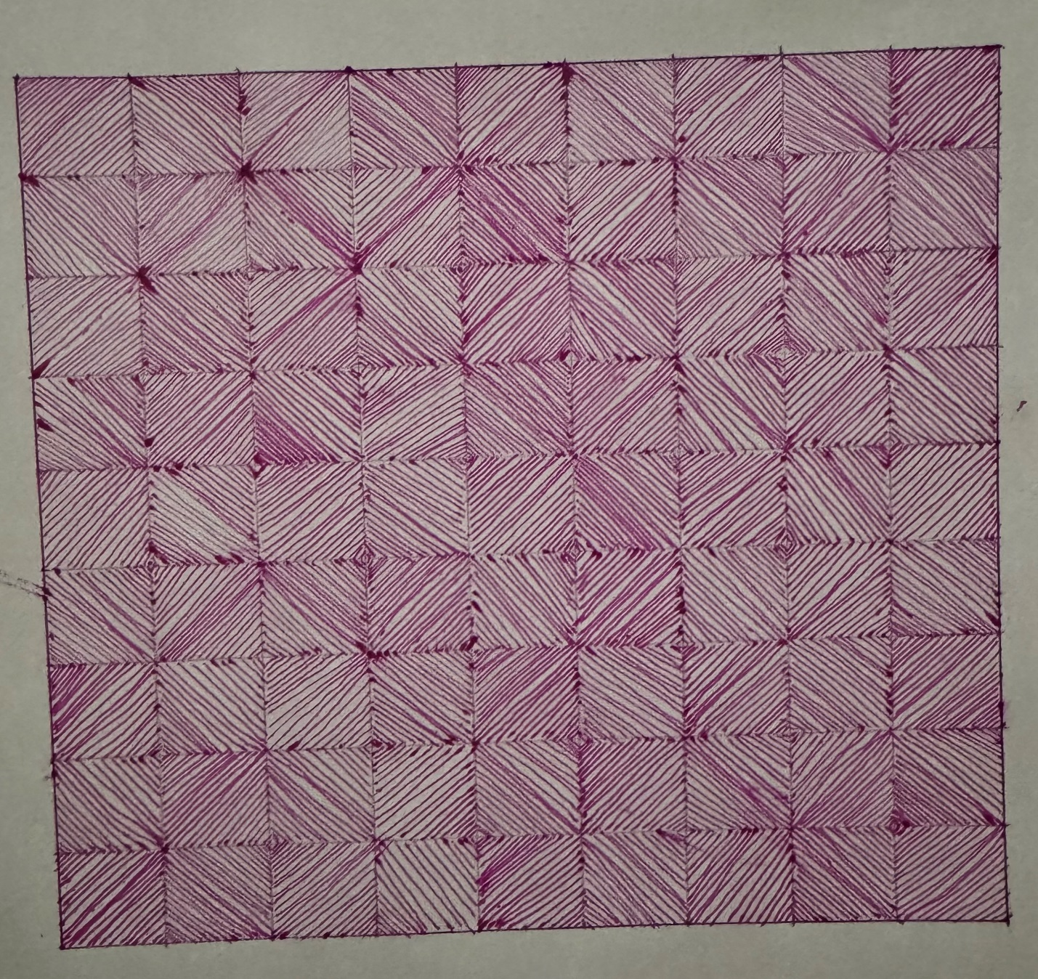

Figure : Picture 5

Title: Tranquility

Tools: Pink color pen on paper

Description: It has no absolute meaning but the purpose of this drawing was to calm my ever-thinking mind.

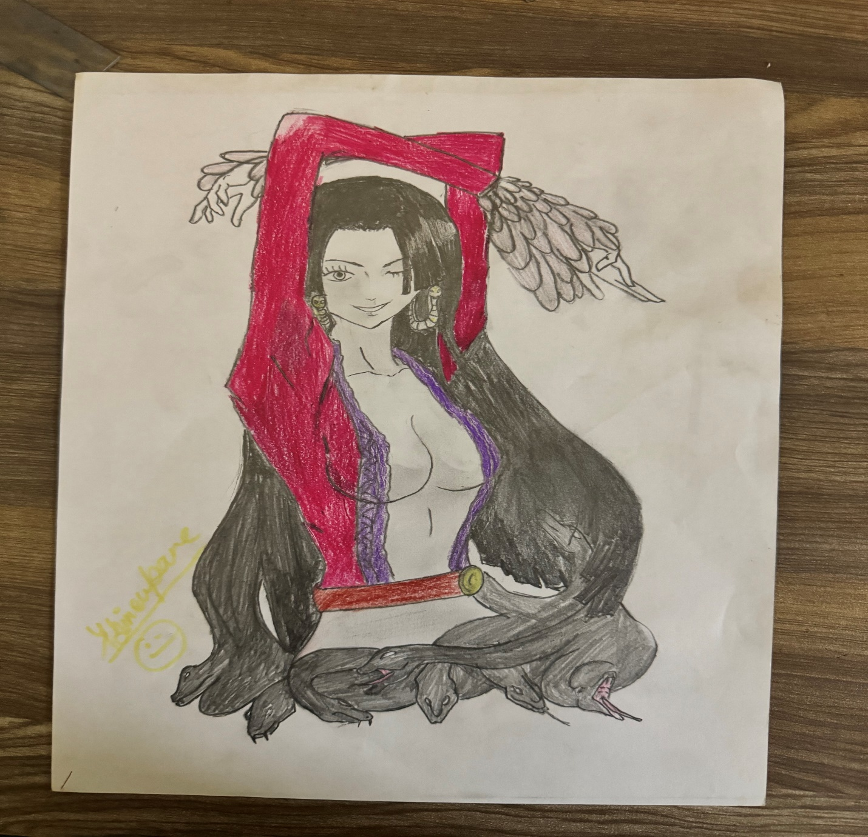

Figure : Picture 6

Title: Boa Hancock

Tools: Graphite pencil, color pencil on paper

Description: This art is simply a drawing of a favorite character from One piece anime that I loved to watch.

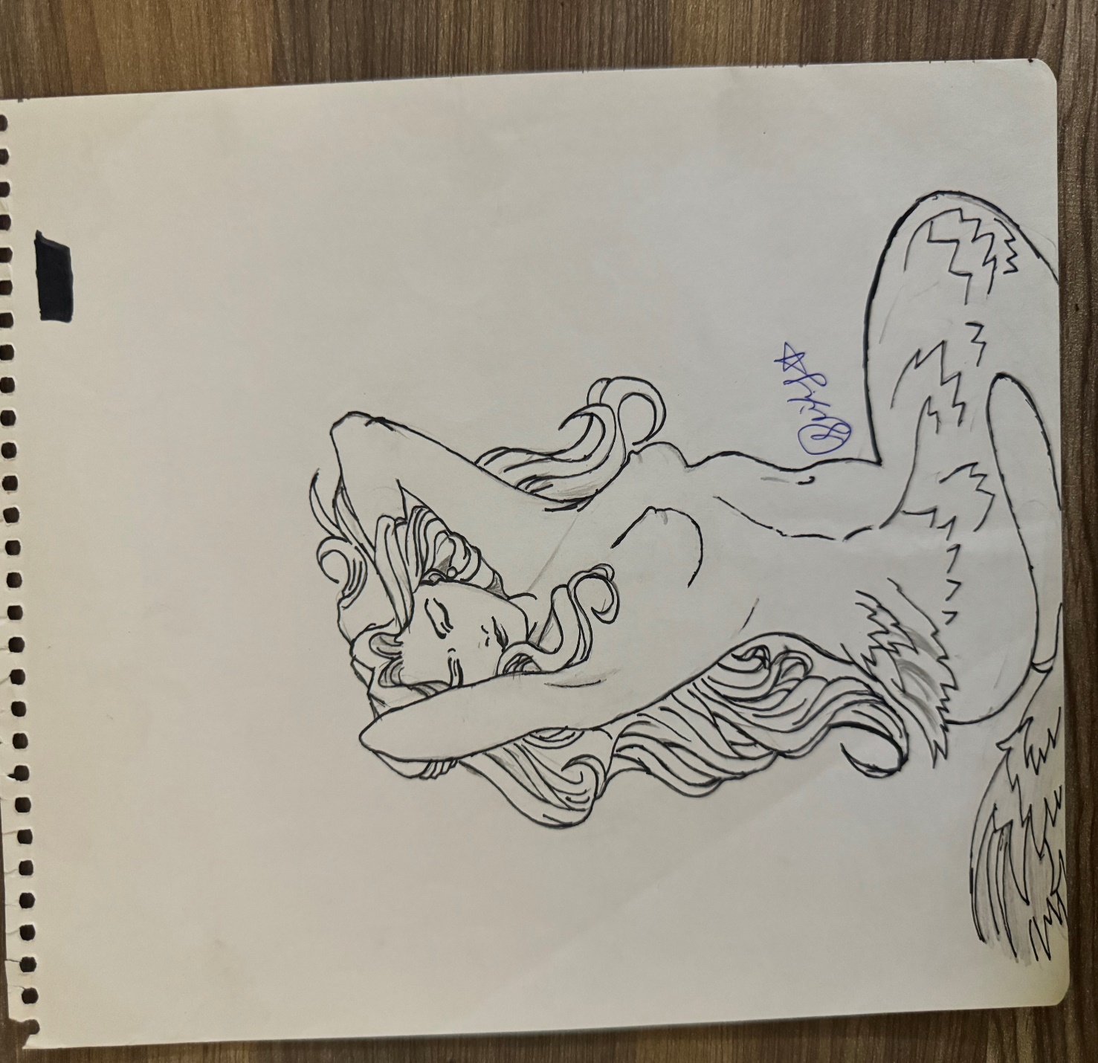

Figure : Picture 7

Title: Water maiden

Tools: graphite pencil, ink pen on paper

Description: During my late teens I was fascinated by mermaid and their ability to live under, that fascination was expressed in this art.

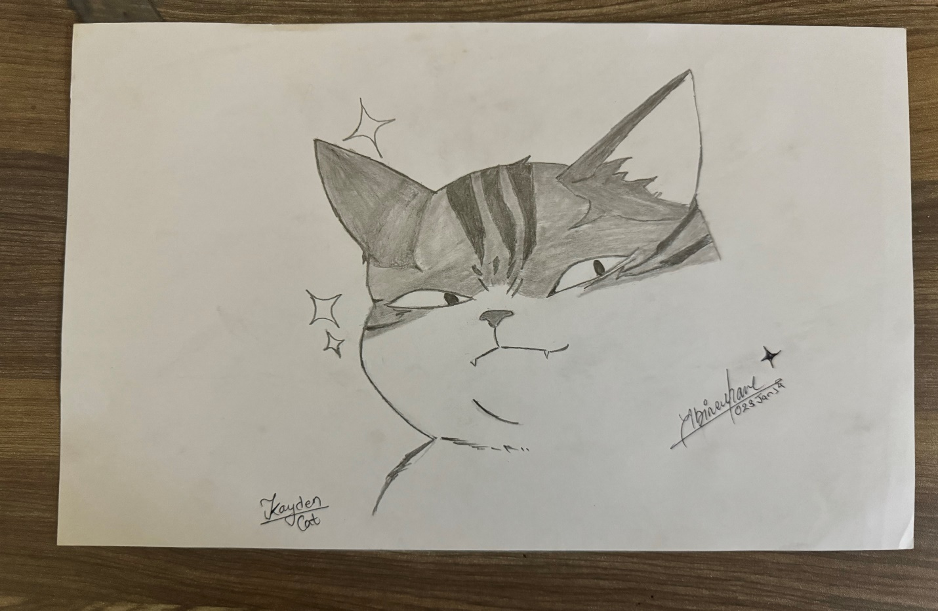

Figure : Picture 8

Title: Kyden

Tools: Graphite pencil on paper

Description: It is a character from the webtoon Elceed, while reading the manga I was captivated by this character and was motivated to draw.

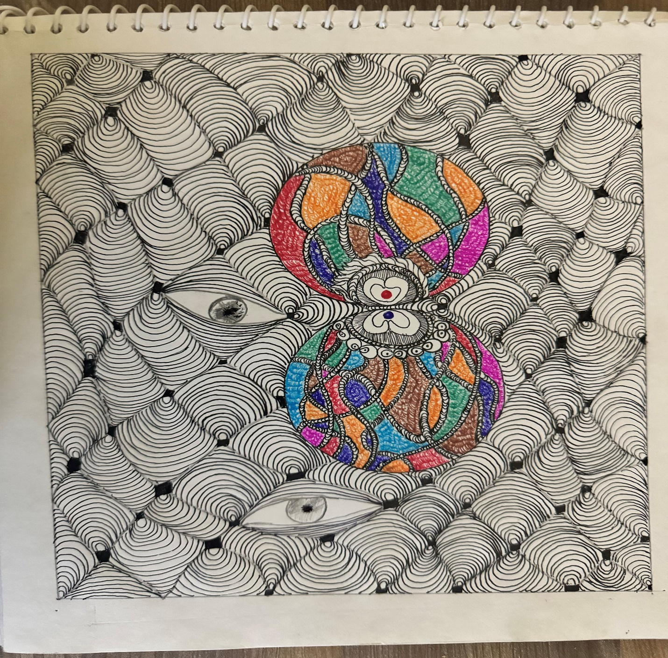

Figure : Picture 9

Title: Searching

Tools: color pen, ink pen on paper

Description: The two circles symbolize my inner desire, thought and emotion, remaining portion displays the confusions I am tackling and the eyes represents my desire to see through all those confusion.

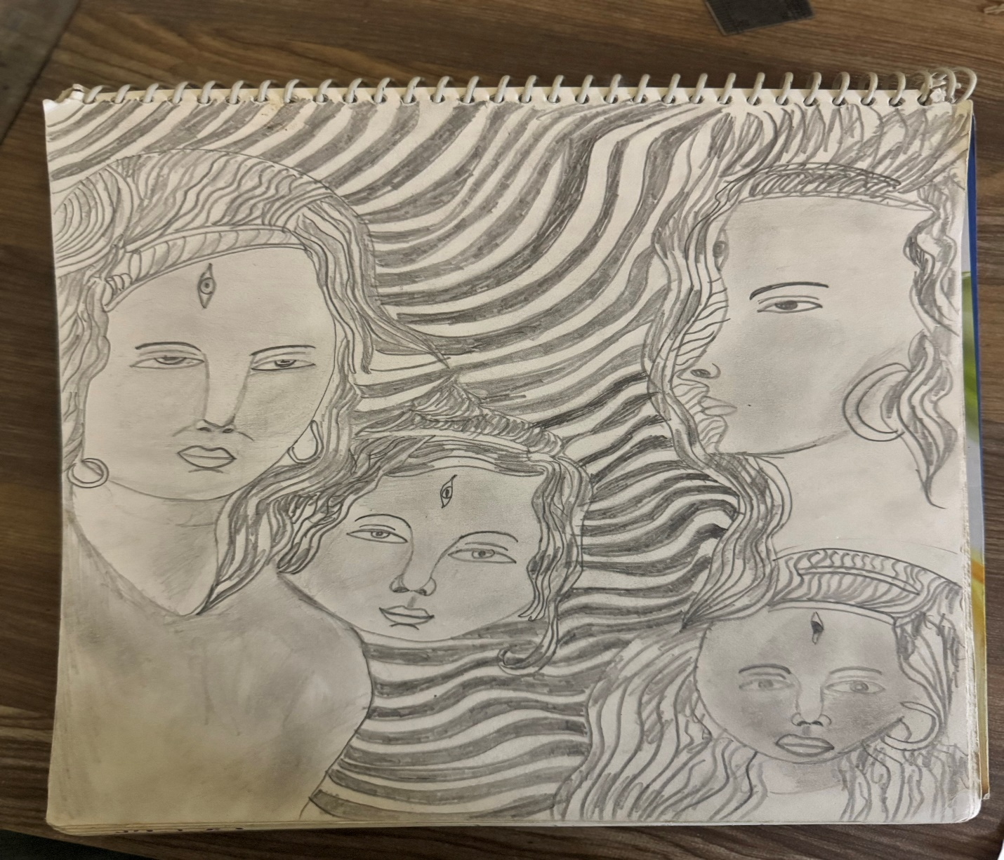

Figure : Figure 10

Title: Irregular Face

Tools: Graphite pencil on paper

Description: It is the oldest art from my collections, this shows my love and dedication that I have for arts.

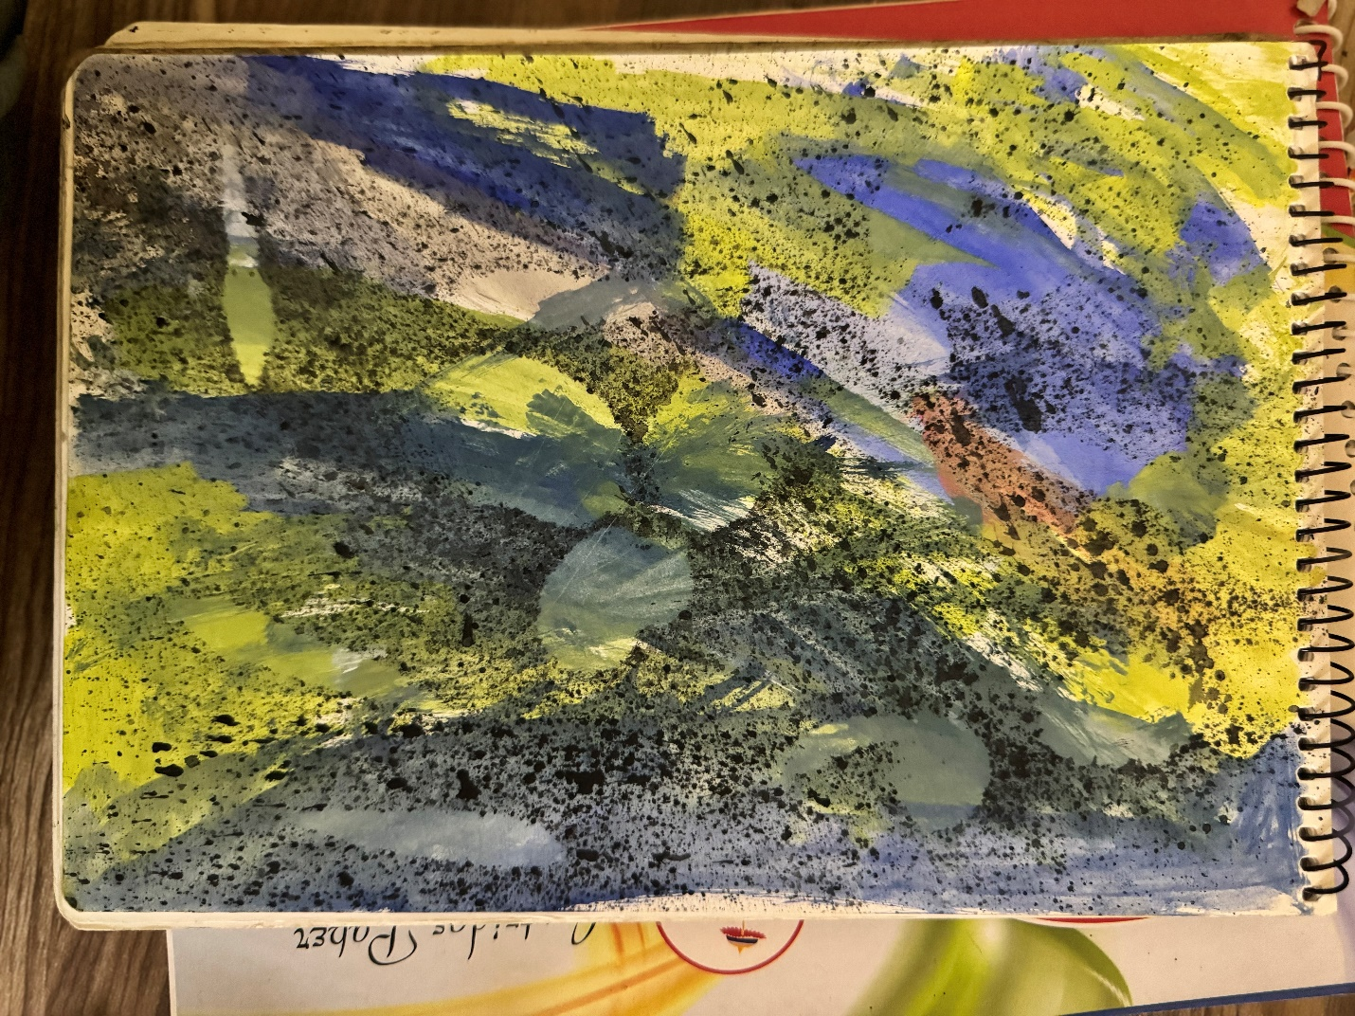

Figure : Picture 11

Title: Experiment

Tools: Paints, leaf, brush on paper

Description: During the art journey I had played with colors many times but this was something that captured my teen characteristics and is one of my favorite. It displays my randomness nature.